


Anguilla Maritime Administration
& Shipping Registry

AMASR

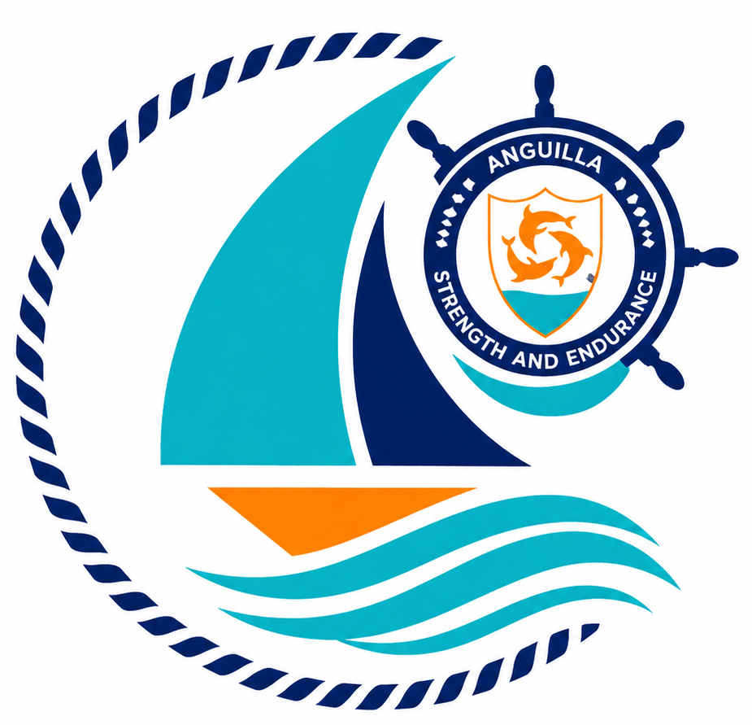

Form: | Application for Exemption
No.: | 07
Rev.: | 02
Date: | 2026-06-10
To: | Recognized Organizations, Shipowners, Managers, Masters, Seafarers, Partners, Brokers, Surveyors, and the general public.

Strength and Endurance

Address: Anguilla Maritime Administration
Anguilla, Leeward Islands, Ministry of Infrastructure, Communications, Utilities and Housing, Coronation Avenue, The Valley Anguilla
Tel: +447454760022| Email: info@amasr.ai

FORM 07 - APPLICATION FOR EXEMPTION
Please complete this form in its entirety, electronically or in block capitals.

PLEASE COMPLETE IN CAPITAL LETTERS IN BLACK INK OR BY TYPING.
NOTE THE DOCUMENTATION CHECKLIST RP28
VESSEL DETAILS
Name of Vessel | Official Number | IMO Number
Vessel Type | Length (ITC 69) | Gross Tonnage (ITC 69)

DETAILS OF OWNER
Name of Owner :
IMO Owner Number (if known) :

We being the Owner/Owner’s Agent *(delete as applicable) of the above mentioned vessel do hereby apply to ANGUILLA MARITIME ADMINISTRATION & SHIPPING REGISTRY for an Exemption Certificate / Letter of Dispensation *(delete as applicable)

1) | Equipment and/or regulation for which the Exemption / Dispensation is requested:

2) | Reasons for requesting the Exemption / Dispensation:

3) | Regulation that grants the right to an Exemption / Dispensation:

4) | Voyage to be undertaken in respect of this Exemption Certificate
  Port & Country of Departure | Port & Country of Arrival | Voyage Duration (in days)

5) | Validity of the Statutory or other Certificate to which the Application for Exemption refers:  (Copy of Certificate to be attached to this request)

6) | Validity of the Statutory or other Certificate to which the Application for Exemption refers:  (Copy of Certificate to be attached to this request)

7) | Special conditions or further remarks:

Signatory full name in block letters | Role
Date | Signature

Note: Refer also to the guidance notes overleaf.

- This application must be signed:

  - by the owner of the vessel, if they are a natural person.
  - by a company director or authorized representative with power of attorney, if the owner is a legal entity.

